**Assignment – 1** **A Job Ready Bootcamp in C++, DSA and IOT**

Input and output in C Language

**1. Write a program to print Hello Students on the screen.**

#include<stdio.h>

int main()

{

printf("Hello");

return 0;

}

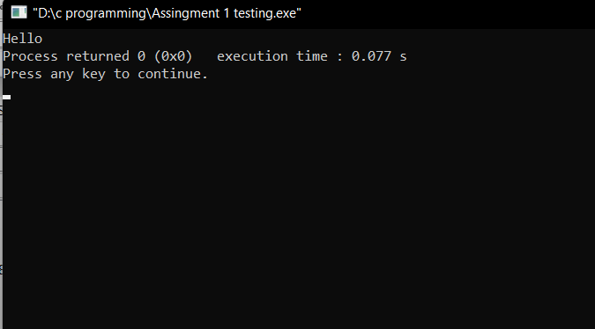

**2. Write a program to print Hello in the first line and Students in the second line.**

#include<stdio.h>

int main()

{

printf("Hello\nStudents");

return 0;

}

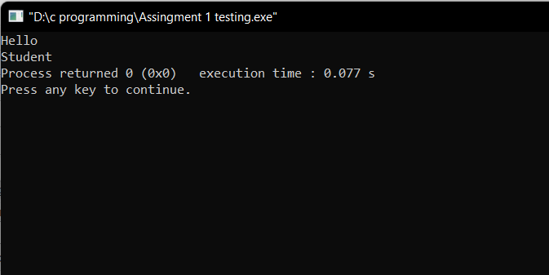

**3. Write a program to print “MySirG” on the screen. (Remember to print in double quotes)**

#include<stdio.h>

int main()

{

printf("\"Hello\"");

return 0;

}

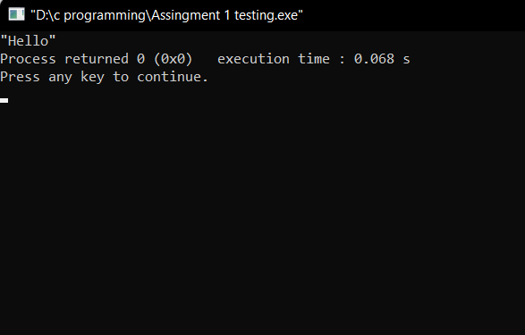

**4. WAP to find the area of the circle. Take radius of circle from user as input and print the**

**result in below given format.**

**Expected output format – “Area of circle is A having the radius R”. Replace A with area**

**& R with radius.**

#include<stdio.h>

int main()

{

float radius,area;

printf("Enter radius of circle ");

scanf("%f",&radius);

area=3.14*radius*radius;

printf("Area of circle is %f having radius %f",area,radius);

return 0;

}

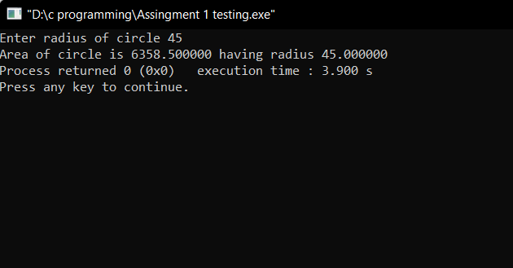

**5. WAP to calculate the length of String using printf function.**

#include<stdio.h>

int main()

{

int r;

r=printf("Aryan ");

printf("%d",r);

return 0;

}

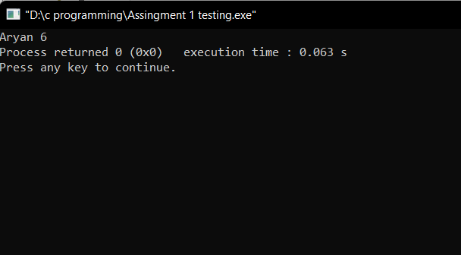

**6. WAP to print the name of the user in double quotes Expected output format – “Hello , Amit Kumar”.**

#include<stdio.h>

int main()

{

printf("\"Hello,Aryan Kumar\"");

return 0;

}

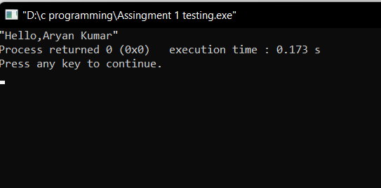

**7. WAP to print “%d” on the screen**.

#include<stdio.h>

int main()

{

printf("%%d");

return 0;

}

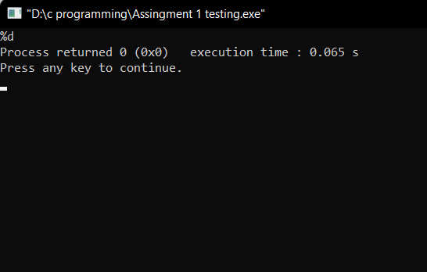

**8. WAP to print “\n” on the screen**.

#include<stdio.h>

int main()

{

printf("\\n");

return 0;

}

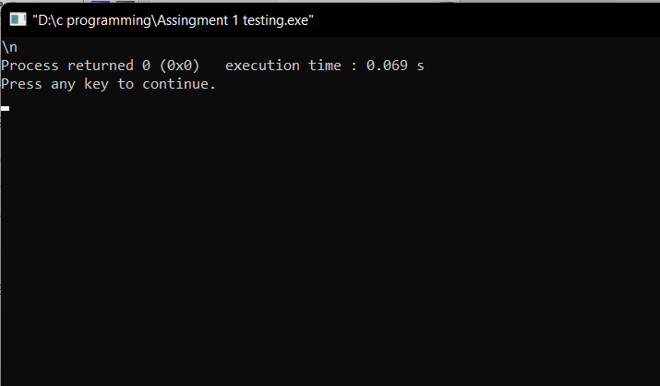

**9. WAP to print “\\” on the screen.**

#include<stdio.h>

int main()

{

printf("\\\\");

return 0;

}

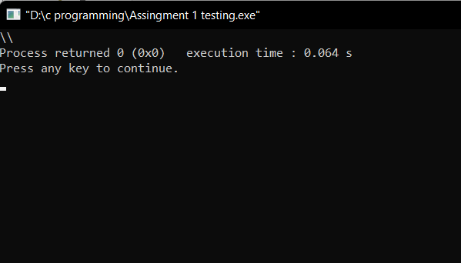

**10. WAP to take date as an input in below given format and convert the date format and**

**display the result as given below.**

**User Input date format – “DD/MM/YYYY” (27/11/2022)**

**Output format –**

**“Day – DD , Month – MM , Year – YYYY” (Day – 27 ,Month – 07 , Year – 2022)**

#include<stdio.h>

int main()

{

int DD,MM,YYYY;

printf("enter date\n");

scanf("%d/%d/%d",&DD,&MM,&YYYY);

printf("Day - %d, Month - %d, Year - %d",DD,MM,YYYY);

return 0;

}

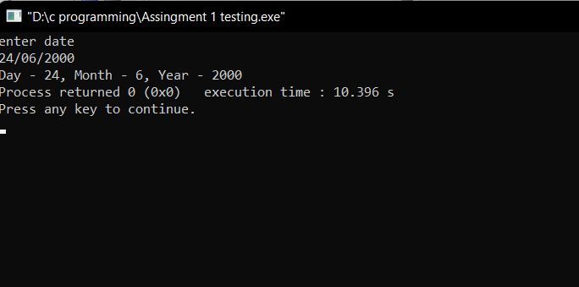

**11. WAP to take time as an input in below given format and convert the time format and**

**display the result as given below.**

**User Input date format – “HH:MM”**

**Output format – “HH hour and MM Minute”**

**Example –**

**“11:25” converted to “11 Hour and 25 Minute”**

#include<stdio.h>

int main()

{

int HH,MM;

printf("Enter Time\n");

scanf("%d:%d",&HH,&MM);

printf("%d Hour and %d Minute",HH,MM);

return 0;

}

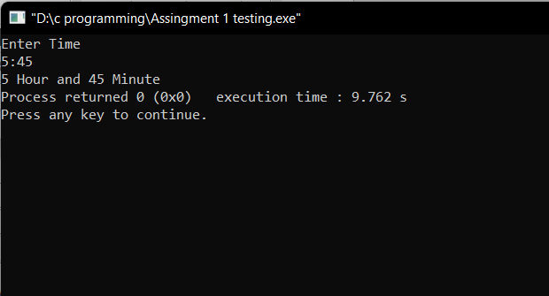

**12. Find output of below code**:

int main()

{

int x = printf(“ineuron”);

printf(“%d”,x);

return 0;

}

Output – ineuron7